**Facial Recognition using Transfer Learning**

1. **Pre-requisites:**

* Download Face Haar Cascade file and rename it to ‘haar.xml’
* Create a folder ‘Dataset’ and inside it create two folders ‘test’ and ‘train’
* Create folders of your family member’s name inside the ‘test’ and ‘train’ folders, **eg-** Suppose you want to recognise faces of three members, Rahul, Ankit, Parth, then you have to create three folders with these names respectively in ‘test’ and ‘train’ folder both
* Collect approx. 1000 images (with different angles) per member for ‘train’ folder, and 300 images approx. for ‘test’ folder and place in respective member’s folder
* Collect some sample images for prediction in dataset folder of all the members

1. **Code:**

* We are using **ResNet50** Architecture for Transfer Learning
* As Resnet50 is pre-created architecture, so we have to provide a dataset, and we are using **ImageNet** here



* Deactivating all trainable layers

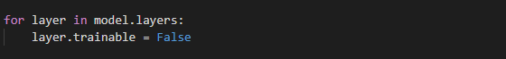

* Creating the new architecture in existing model, **top_model** is the ResNet50 model, and we included three layers for recognition in top_model hence creating **new_model** for the final architecture

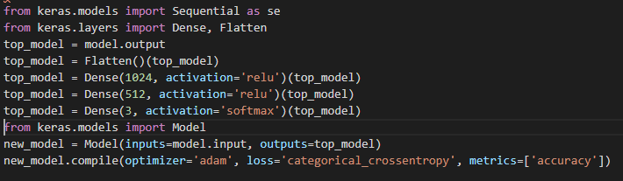

* Now, fitting the model with our Dataset with **Image Augmentation**
* **3000** is the total no of images in ‘train’ folder (1000 images per member), and **900** is the total images in ‘test’ folder (including 300 images per member)

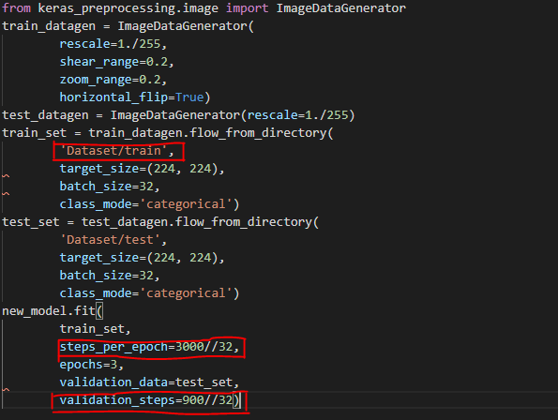

* Saving the model with name **‘face_rec.h5’**
* **‘value’** variable will give the indexing associated with members respectively **eg**- Rahul : 0, Ankit : 1, Parth : 2
* Hence, the prediction will be as per index basis

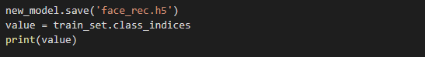

* The sample images which we saved in the **‘Dataset’** folder will help us in prediction (in my case, **3.jpeg** is used)
* **‘pred’** will give the recognition result in integer format associated with the member

